Radio-Canada 2020
For the first time in ten years, a Canadian has won the London Wheelchair Marathon. Brent Lakatos of Dorval won in 1 h 36 min 4 s ahead of Briton David Weir and Olympic marathon champion Swiss Marcel Hug.
In difficult conditions, in the rain and in the cold London, Lakatos was able to stand up to the strength of his arms to the tenors of the discipline, including David Weir, eight-time champion.
It was raining a lot and it was around 12 degrees, but when it started, I felt good and I had a good coat to block the rain , said the Quebec athlete.
Lakatos, a sprint specialist, kept his cool throughout the event and edged his rivals by several lengths in the home stretch near Buckingham Palace.
At 40, he became the first Canadian since Josh Cassidy in 2010 to win the London Marathon. Pandemic requires, the race took place behind closed doors in St-James Park. The athletes had to complete 19 loops of just over 2 kilometers. Four 500m sprints scheduled during the event offered the faster runner a financial reward.
It was a more strategic race because the guys wanted to maintain their power for the sprints, Lakatos said. Everyone then slowed down and we had to manage our energy accordingly. It was a race where the speed changed a lot and it was very good for me.
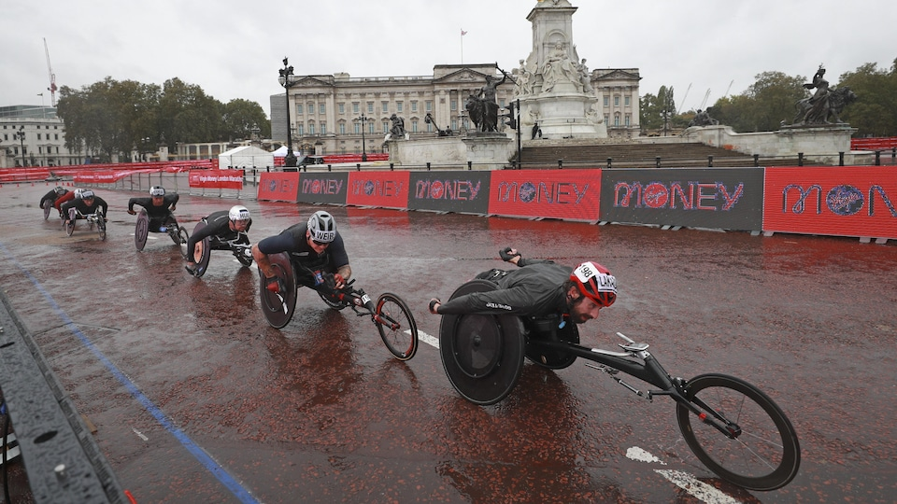
Brent Lakatos
PHOTO: AP
Lakatos, who also won the Berlin Marathon in 2018, has a long track record. At the Para-Athletics World Championships in 2019, the Quebecer won two gold medals in the 100 and 800m and a silver medal in the 400m.
At the same competition, in 2017, he won four gold medals in the 100m, 200m, 400m and 800m.At the Rio Games, a year earlier, he also came home with a harvest of four medals, gold in the 100m, silver in the 400m and bronze in the 800m and the 4x400m relay.The Dutch Nikita Den Boer won in the women's section. She crossed the distance in 1:40:07.

