Brent Lakatos captures world gold in Paris for 3rd Para athletics medal in 5 days

5-time Paralympian beats Thailand's Paeyo by 8-100ths of a second in 800m race
CBC Sports · Posted: Jul 15, 2023 4:17 PM ADT | Last Updated: 6 minutes ago
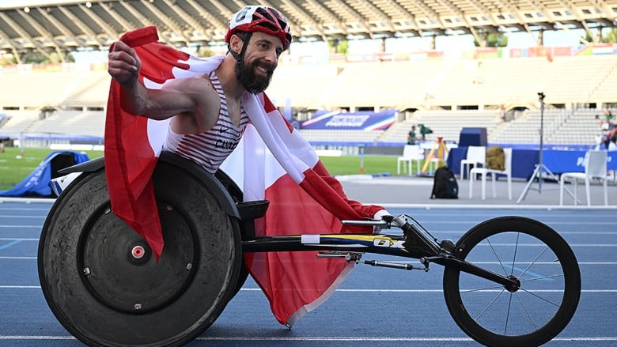
Brent Lakatos of Dorval, Que., won Para athletics world gold in a championship record time of one minute 34.31 seconds in the men's T53 800-metre final on Saturday in Paris. It's the 43-year-old's third medal of the week after he collected silver in the 400 and 1,500. (Matthias Hangst/Getty Images)
comments
Canada's Brent Lakatos earned his 12th career gold medal at the Para athletics world championships on Saturday, crossing the finish line in the men's T53 800-metre final in a record one minute 34.31 seconds on a sunny evening at Charléty Stadium in Paris.
It was a wire-to-wire victory for the 43-year-old from Dorval, Que., who captured silver in the men's T54 1,500 on Friday after placing second in Tuesday's T53 400.
Pongsakorn Paeyo closed the gap on Lakatos as they entered the final 100 metres but the latter held off his Thai opponent for his 18th world medal (four silver, two bronze).
Paeyo clocked 1:34.39 after winning 400 gold Tuesday in world record time (1:46.11).
He also defeated Lakatos across 800 metres in the 2020 Paralympic final, clocking a Games record 1:36.07 in a driving rain in Tokyo after the Canadian couldn't maintain his first-lap lead and reached the finish in 1:36.62.
American Brian Siemann picked up bronze on Saturday in a 1.36.65 season best.
Lakatos, who has amassed 10 medals at five Paralympics, is competing at his seventh worlds.
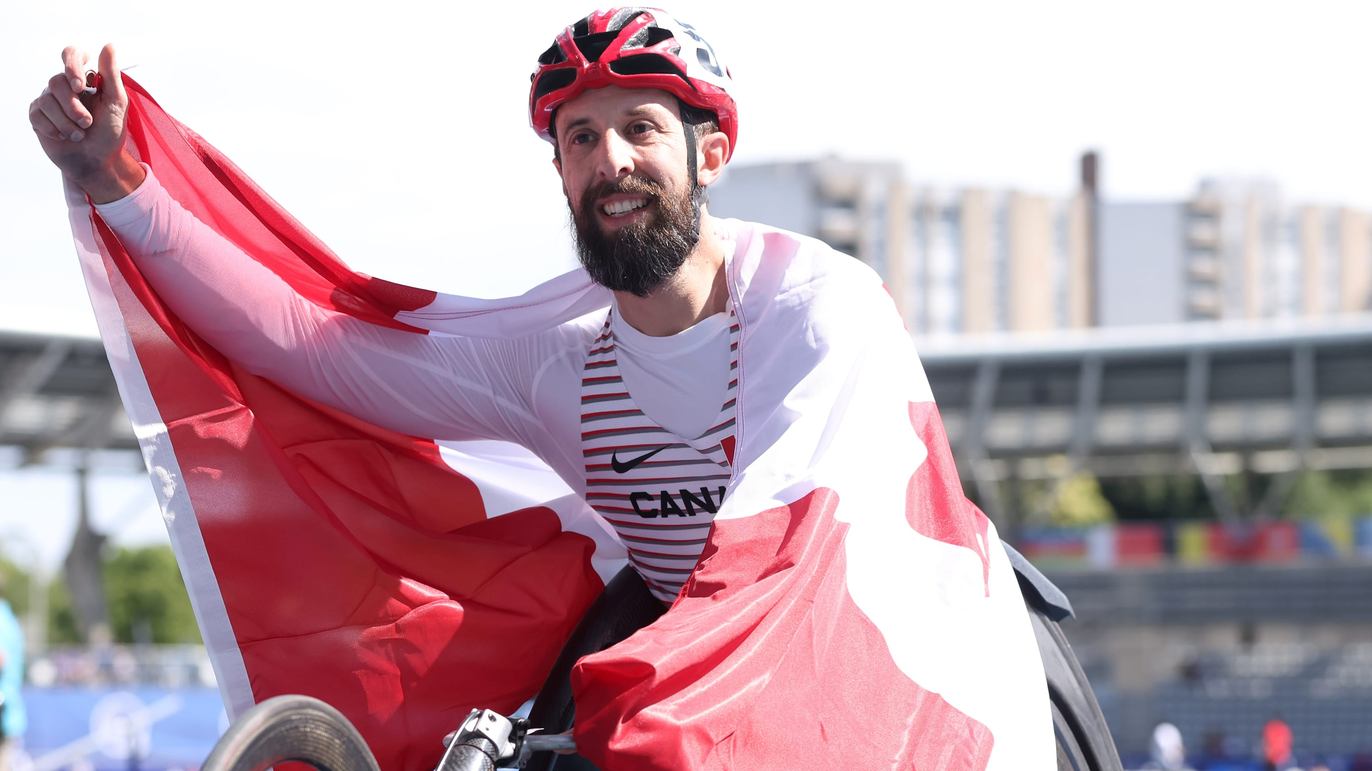

Brent Lakatos captures gold at the World Para Athletics Championships
3 hours ago
Duration7:16
Brent Lakatos of Dorval, Que., dominates the Men's 800m T53 and captures his third medal, his first gold, at the 2023 World Para Athletics Championships in Paris. The victory represents his 12th world championship, and his third medal of this competition.

